MIRT Class Assignment

Run an Polytomous IRT analysis on the data from a scale covering generalized life purpose.

1. Reverse code items: 5, 8, 13 for a 1-7 Likert scale. DONE
2. Calculate a GPCM on the data.
3. Include the following:
   1. ICCs for the GPCM the overall plot.

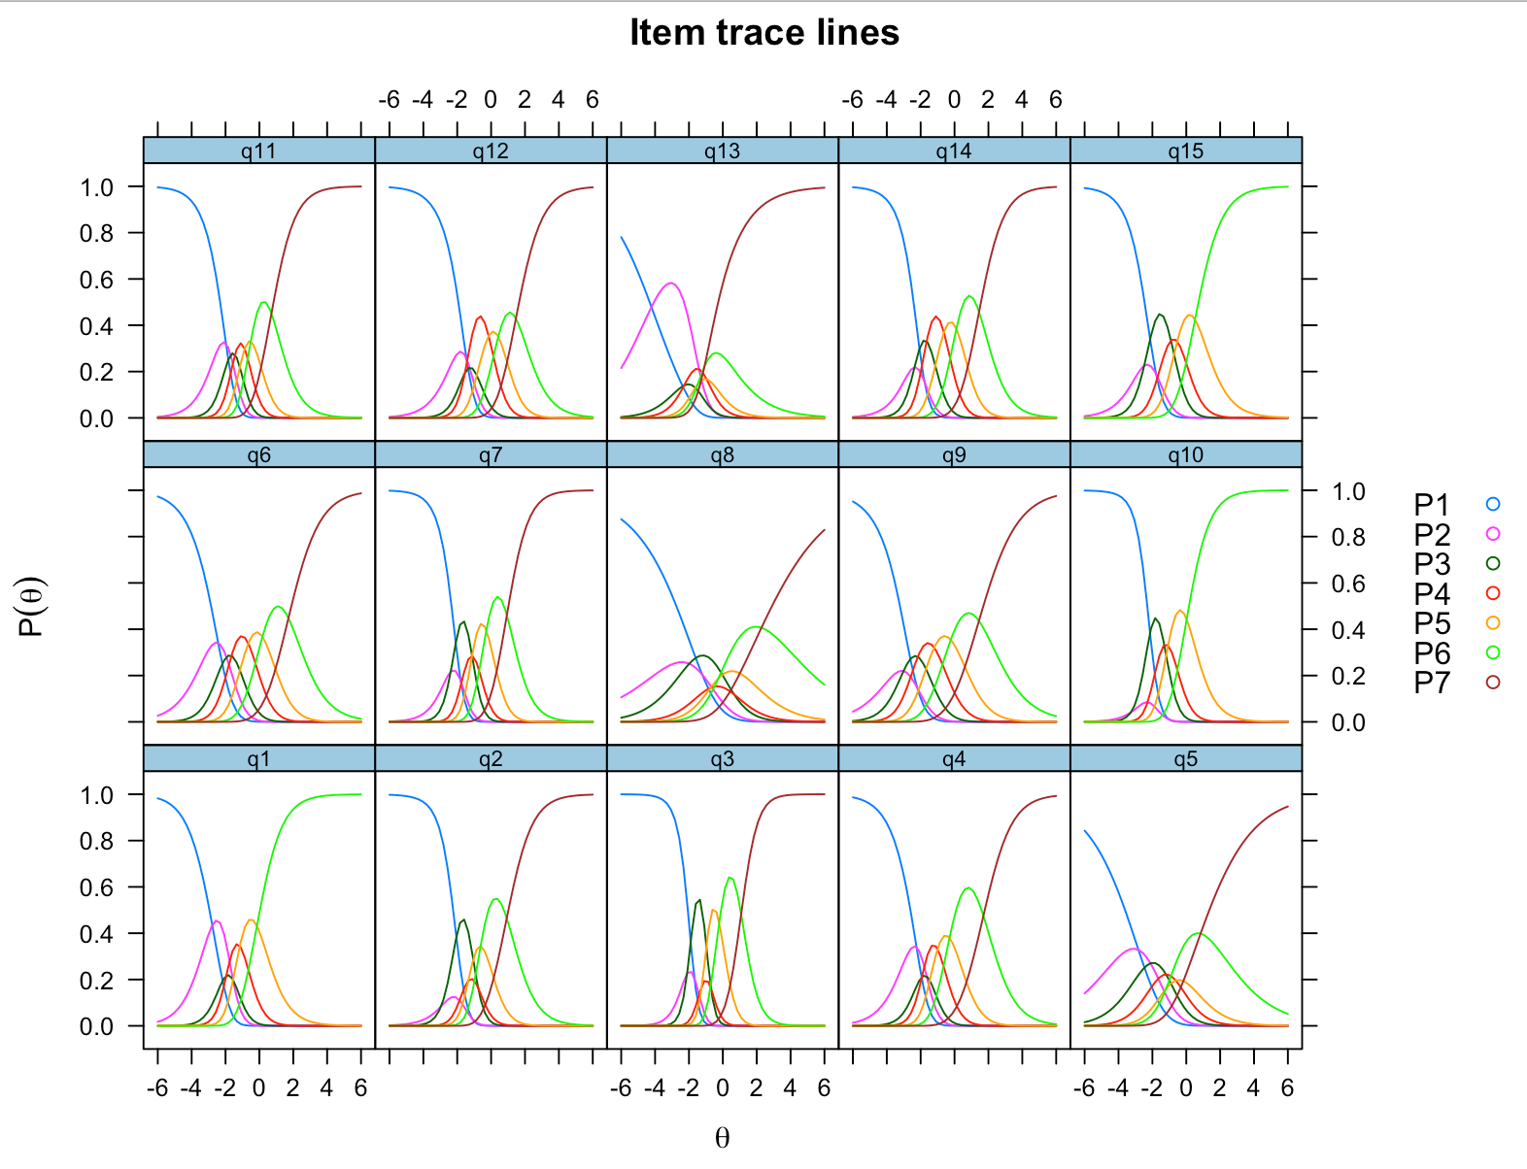

* 1. TIF for the GPCM.

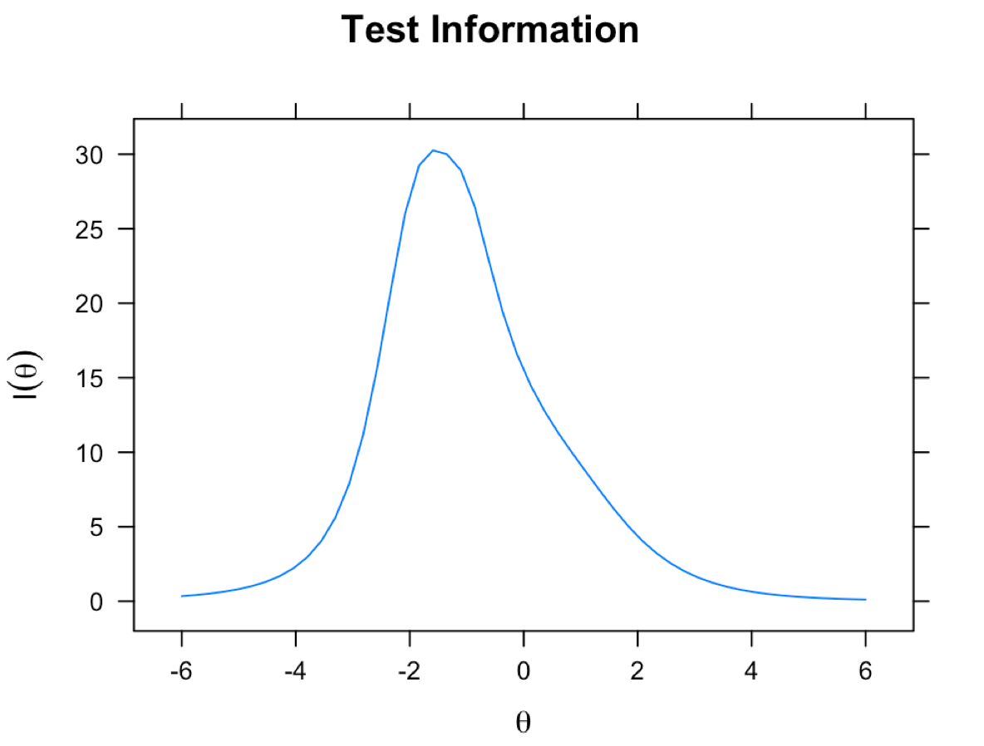

1. Do the items appear to load onto one factor? Include the summary.

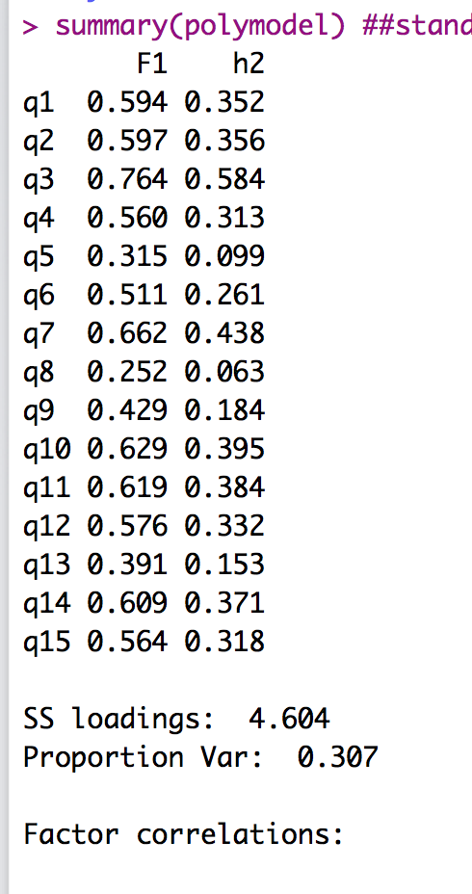

1. Interpret your findings:
   1. Items:
      1. Which questions are good items for discrimination? BAD: 5, 8, 9, 13 poor items due to low a values.
      2. Which questions measure below average ability? ALL of them!
      3. Which questions measure above average ability? None, maybe some of 12
      4. Use *a*, item traces, and IICs for the above questions to answer them.

> coef(polymodel, IRTpars = T) ##coefficients

$q1

a b1 b2 b3 b4 b5

par 1.256 -2.782 -1.562 -1.957 -1.154 -0.145

$q2

a b1 b2 b3 b4 b5 b6

par 1.266 -1.148 -2.956 -0.77 -1.341 -0.62 0.924

$q3

a b1 b2 b3 b4 b5 b6

par 2.018 -1.685 -2.107 -0.7 -1.239 -0.215 1.083

$q4

a b1 b2 b3 b4 b5 b6

par 1.15 -2.245 -1.647 -1.923 -1.002 -0.296 1.704

$q5

a b1 b2 b3 b4 b5 b6

par 0.565 -2.824 -2.112 -1.194 -0.619 -1.187 0.848

$q6

a b1 b2 b3 b4 b5 b6

par 1.011 -2.433 -1.945 -1.646 -0.654 0.18 1.716

$q7

a b1 b2 b3 b4 b5 b6

par 1.502 -1.793 -2.382 -1.126 -1.123 -0.282 0.931

$q8

a b1 b2 b3 b4 b5 b6

par 0.442 -1.222 -1.983 0.664 -0.719 -0.266 2.281

$q9

a b1 b2 b3 b4 b5 b6

par 0.809 -2.206 -3.01 -2.169 -1.203 -0.224 1.442

$q10

a b1 b2 b3 b4 b5

par 1.376 -1.015 -3.263 -1.298 -1.072 0.024

$q11

a b1 b2 b3 b4 b5 b6

par 1.343 -1.973 -1.698 -1.438 -0.869 -0.51 0.712

$q12

a b1 b2 b3 b4 b5 b6

par 1.2 -1.457 -1.273 -1.545 -0.146 0.422 1.464

$q13

a b1 b2 b3 b4 b5 b6

par 0.722 -4.214 -0.531 -2.284 -0.964 -1.47 -1.079

$q14

a b1 b2 b3 b4 b5 b6

par 1.306 -1.782 -2.359 -1.645 -0.628 0.108 1.448

$q15

a b1 b2 b3 b4 b5

par 1.162 -1.783 -2.483 -0.905 -0.532 0.516

* 1. Answers:
     1. Do the item choices appear ordered? They appear to be in order mostly.
     2. Are the choices all probable at some point of ability? NO, generally only 4-5 of the points are likely at some point.